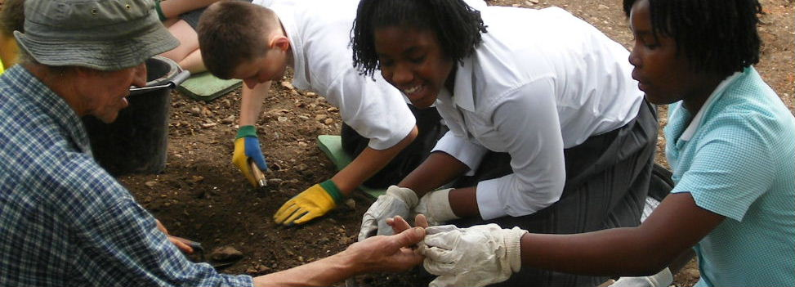

Michael Faraday Community Excavation
25th June – 6th July 07
Contents
National Curriculum links
and session description 3
Timetable 4
Practical Guidelines 5
Pre-visit activities 6
Follow-up activities 7
Planning your journey 11

Curriculum links
KS2 History
The visit will link to History, Geography, Citizenship, literacy and numeracy. Pupils will learn how archaeology informs us about the lives and experiences of people and significant events and changes. Through historical enquiry and working with primary sources your pupils will develop knowledge of the local social history in the 18th – 20th centuries.
Session description
The dig
At your allocated time your group will be welcomed by the Site Supervisor, an archaeologist, who will talk about archaeology and then run the session as if the pupils are his team excavating a site. The workshop is in three stages:
- Group briefing (15 minutes)
The group will be divided in half, each will do one activity and then they will swap over.
- The excavation (40 minutes)
Ten minutes to swap activities
- Finds processing (40 minutes)
- Group discussion (10 minutes)

To ensure that the pupils are adequately supervised please make sure that you have an adult to child ratio of 1 to 8. Please encourage adults to take part in the excavation.

The group briefing will cover an introduction to the site, this history of the area, what is archaeology and the job of an archaeologist.
There will be one trench for the excavation and there will be mainly 18th century and Victorian remains but there may also be more modern material. Pupils will be taught how to dig and retrieve finds. They will be provided with all the tools they need.
The finds processing will involve washing the finds both from the site and other London sites. Pupils will be taught about different materials and how to identify objects.
A Site Supervisor will interpret the pupils’ findings in a group discussion session at the end of the workshop.
The excavation will help your pupils’ understanding of archaeology, Victorian Britain and social history, and the archaeologist will welcome questions from your pupils.

Timetable
The session will run once only and at the times stated below so please arrive on time. There will be schools booked for the other sessions and you will not be able to overrun your allocated time.
You group has been allocated ONE of the following sessions; please check your confirmation letter:

Group 1
10.00am Arrival and introduction. After the introduction the group divides in half. Half go to
the first activity and half go to the second and then they swap over.
10.15am – 10.55am The excavation/finds processing
10.55am – 11.05am Swap activities
11.05am – 11.45am Finds processing/the excavation
11.45am – 11.55am Group reunites for a summary discussion of findings

Group 2
1.00pm Arrival and introduction. After the introduction the group divides in half. Half go to
the first activity and half go to the second and then they swap over.
1.15pm – 1.55pm The excavation/finds processing
1.55pm – 2.05pm Swap activities
2.05pm – 2.45pm Finds processing/the excavation
2.45pm – 2.55pm Group reunites for a summary discussion of findings

Practical Guidelines
Session
The dig will take place in the playground of the Michael Faraday Primary School. There will be signs on the nearest gate.
Drinks
Please bring your own drinks, especially during hot weather. There are drinking water fountains in the playground that can be used during the ten minute swap over period between activities.

Photography
During sessions photography is welcomed.

Risk assessments
It is the responsibility of the group leader to carry out a risk assessment and teachers are encouraged to make a planning visit and to carry out their own assessment. The Museum has written a risk assessment and this is included but this is only for teachers’ information and does not constitute an official document.

Organising your group
Split your class into two groups for working on the activities. Please ensure that you have at least one adult for every ten pupils and that the adults accompany them at all times. Please ensure the children know the following information:
- Work quietly – please respect that the Michael Faraday pupils are working in their classrooms.
- Take care in and around the trench
- Pre-visit activities

We highly recommend doing one or more of these three activities before the session.
- Collect items of rubbish made from a range of materials – for example paper, organic waste (e.g. a banana skin), metal, plastic, pottery, wood, glass, leather and fabric. Record the condition of the items of rubbish using drawings, descriptions or photographs. In a controlled experiment bury the items of rubbish in soil outside the classroom, mark the site and leave for 1 month. During this time ensure that the objects become wet. Dig the objects up and look at how they have deteriorated. Which objects have deteriorated most? How have they changed? Discuss what might have caused the materials to deteriorate and why some have deteriorated more than others.
- Discuss what the pupils think an archaeologist does and what equipment and protective clothing they need to do their job efficiently and safely. Ask the pupils to draw a picture of an archaeologist with their equipment and clothing labelled.
- Take some pottery, cups and plates for example, and smash them into several pieces, making sure they are not too sharp. Mix up the pottery fragments and ask pupils to sort them and fit them back together to form the original shape. A tray of sand will help support the fragments as the pupils reconstruct the object. This activity will encourage pupils to imagine the size and shape of the original pot from a fragment. Discuss the fact that the majority of things found by archaeologists are fragments and that these provide clues about the complete objects that people made and used in the past.

In addition, you may like to browse the following online resources for introducing pupils to the site and the themes and concepts they will encounter during their visit:
Museum of London Archaeological Archive and Research Centre (LAARC) website
The LAARC website contains information about the site and ongoing results.
www.museumoflondon.org.uk/LAARC

Flickr and Wetpaint
Just search under LAARC or Michael Faraday Community excavation and you will find recently uploaded images and a blog will the latest experiences and findings. Feel free to add your opinion or experiences to the blog!
www.flickr.com and www.wetpaint.com

Museum of London: Digging up the Romans
Your pupils may also find the online activity called “Digging up the Romans” a fun learning experience. This section of our website can be found at:
www.museumoflondon.org.uk/MOLsite/learning/features_facts/digging/index.html

Portable Antiquities Scheme – PASt Explorers
PASt Explorers is a digital educational resource for Key Stage 2 History, History and ICT, Geography and ICT and STEM. This website can be found at:
www.PAStexplorerers.org.uk
Follow up activities for the classroom
These activities are designed to apply and extend knowledge gained from your visit to the Museum of London’s community dig.

- Your digging experience
Add your digging experience to the Museum of London blog on www.wetpaint.com, just search for LAARC (London Archaeological Archive and Research Centre) or Michael Faraday Community Excavation and you will find our account. Or check for new images from the dig on www.flickr.com, use the same searches to find our pictures.

- School underground
Imagine that you are archaeologists in 2201 and that you have discovered the remains of your school buried underground. The building was destroyed many years ago and all that remains are the foundations. Draw a plan of your school, showing the position of walls and label the different parts of the building. Discuss what clues might be left to archaeologists of the future to interpret what the building was used for.

- Rubbish detectives
What might archaeologists in the future think about us if they looked at the things we throw away? Collect some (safe) rubbish and examine it for clues about you and your lifestyle

- Fantastic find
Imagine that you are an archaeologist excavating the house of a poor Victorian family. Ask pupils to write and illustrate a story describing how they excavated the site, what they found and how they felt when they discovered the house.

- Stratigraphy time line.
Ask pupils to gather pictures of people and events from prehistoric times through to the present day. Display these in your classroom as a vertical timeline with the prehistoric pictures at the bottom and the modern ones at the top. They could annotate the pictures with events and dates. Discuss how over the course of history people have lived on the sites of older communities and how their houses, streets and rubbish are put on top of the remains of older settlements.

Planning your journey
Museum of London Community Excavation in Michael Faraday Primary School
Free Session

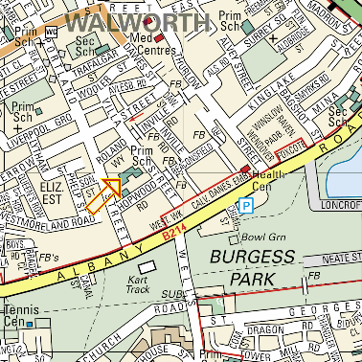
www.multimap.com

Michael Faraday Primary School
Portland Street, Walworth
London SE17 2HR

For more information contact:
Kate Sutton
Finds Liaison Officer and Community Archaeologist
020 7814 5733
ksutton@museumoflondon.org.uk

Free Travel
All schools within the Greater London area can take advantage of Transport for London’s School Party Travel Scheme. See www.tfl.gov.uk/schoolparty or call London Underground Customer Services on 0845 330 9881 for details.

